LAB EXPERIMENT RECORD
Set 7: Customer Demographics Analysis
Department | AIML
Course Code / Course Name | DSA0601 / Data Handling and Visualization
Experiment | Data Visualization using R and Tableau
Name | G. GANGA CHANDRIKA
Register Number | 1925260144
Date | 3 October 2026
Day | Saturday
Aim
To analyse customer demographics by visualizing customer ages with a bar chart, customer gender distribution with a pie chart, displaying the demographic data in a labelled table using R, and combining all three in an interactive Tableau dashboard.
Dataset: Customer Demographics
Customer ID | Age | Gender | Income (in $)
1 | 28 | Female | 50000
2 | 35 | Male | 60000
3 | 42 | Female | 75000
PROGRAM 1: Bar Chart of Customer Ages
Create a bar chart to visualize the distribution of customer ages. Label the axes and title the chart.
# Customer Demographics Dataset
customer_data <- data.frame(
Customer_ID = c(1, 2, 3),
Age = c(28, 35, 42),
Gender = c("Female", "Male", "Female"),
Income = c(50000, 60000, 75000)
)

# Bar Chart for Customer Ages
barplot(
customer_data$Age,
names.arg = customer_data$Customer_ID,
xlab = "Customer ID",
ylab = "Age",
main = "Distribution of Customer Ages"
)
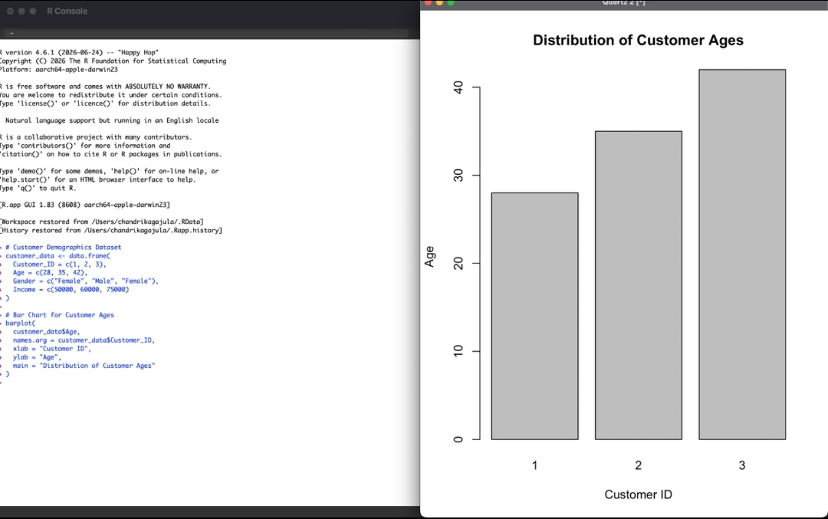
Output 1: Bar Chart of Customer Ages
Observation: The bar chart shows the age of each customer. Customer 3 is the oldest (42 years) and Customer 1 is the youngest (28 years). Age increases steadily from Customer 1 to Customer 3.
PROGRAM 2: Pie Chart of Customers by Gender
Generate a pie chart to represent the distribution of customers by gender.
# Count customers by gender
gender_count <- table(customer_data$Gender)

# Pie Chart
pie(
gender_count,
labels = names(gender_count),
main = "Distribution of Customers by Gender"
)
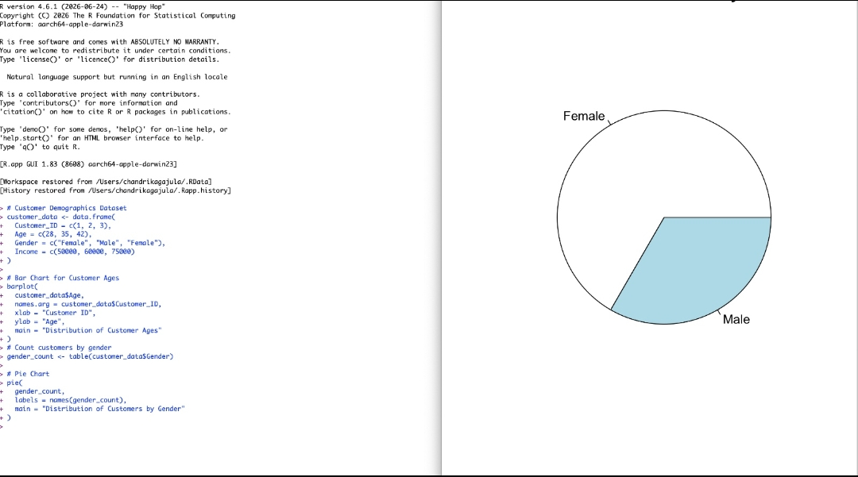
Output 2: Pie Chart of Customer Gender Distribution
Observation: Out of the 3 customers, 2 are Female (about 67%) and 1 is Male (about 33%), so female customers form the larger share.
PROGRAM 3: Customer Demographics Table
Build a table to show the demographic information for each customer. Label the table elements.
# Customer Demographics Data
customer <- data.frame(
Customer_ID = c(1, 2, 3),
Age = c(28, 35, 42),
Gender = c("Female", "Male", "Female"),
Income = c(50000, 60000, 75000)
)

# Label the table columns
colnames(customer) <- c(
"Customer ID",
"Age (Years)",
"Gender",
"Income ($)"
)

# Display the table
customer
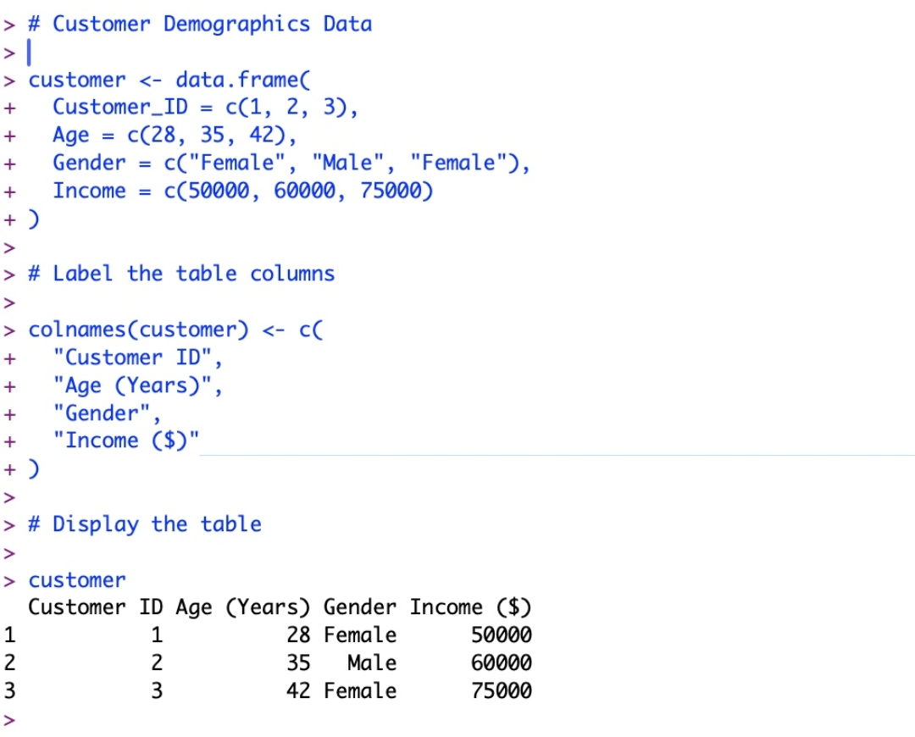
Output 3: Customer Demographics Table
Observation: The table lists the Customer ID, Age (Years), Gender and Income ($) of every customer. Income rises with age, from $50,000 for the 28-year-old to $75,000 for the 42-year-old.
PROGRAM 4: Tableau Dashboard
Develop a Tableau dashboard combining the bar chart, pie chart, and the table for interactive exploration of customer demographics.
Steps followed in Tableau:
1. Connect Tableau to the Customer Demographics data (Excel/CSV).
2. Create a sheet "Bar Chart - Customer Age" with Customer ID on Columns and Age on Rows.
3. Create a sheet "Pie Chart - Gender Distribution" using the Pie mark type, with Gender on Color and Count of Customers on Angle.
4. Create a sheet "Customer Demographics Table" with Customer ID, Age, Gender and Income as text columns.
5. Create a new Dashboard and drag the three sheets onto it.
6. Enable "Use as Filter" on the charts so that selecting a bar or slice filters the other views.
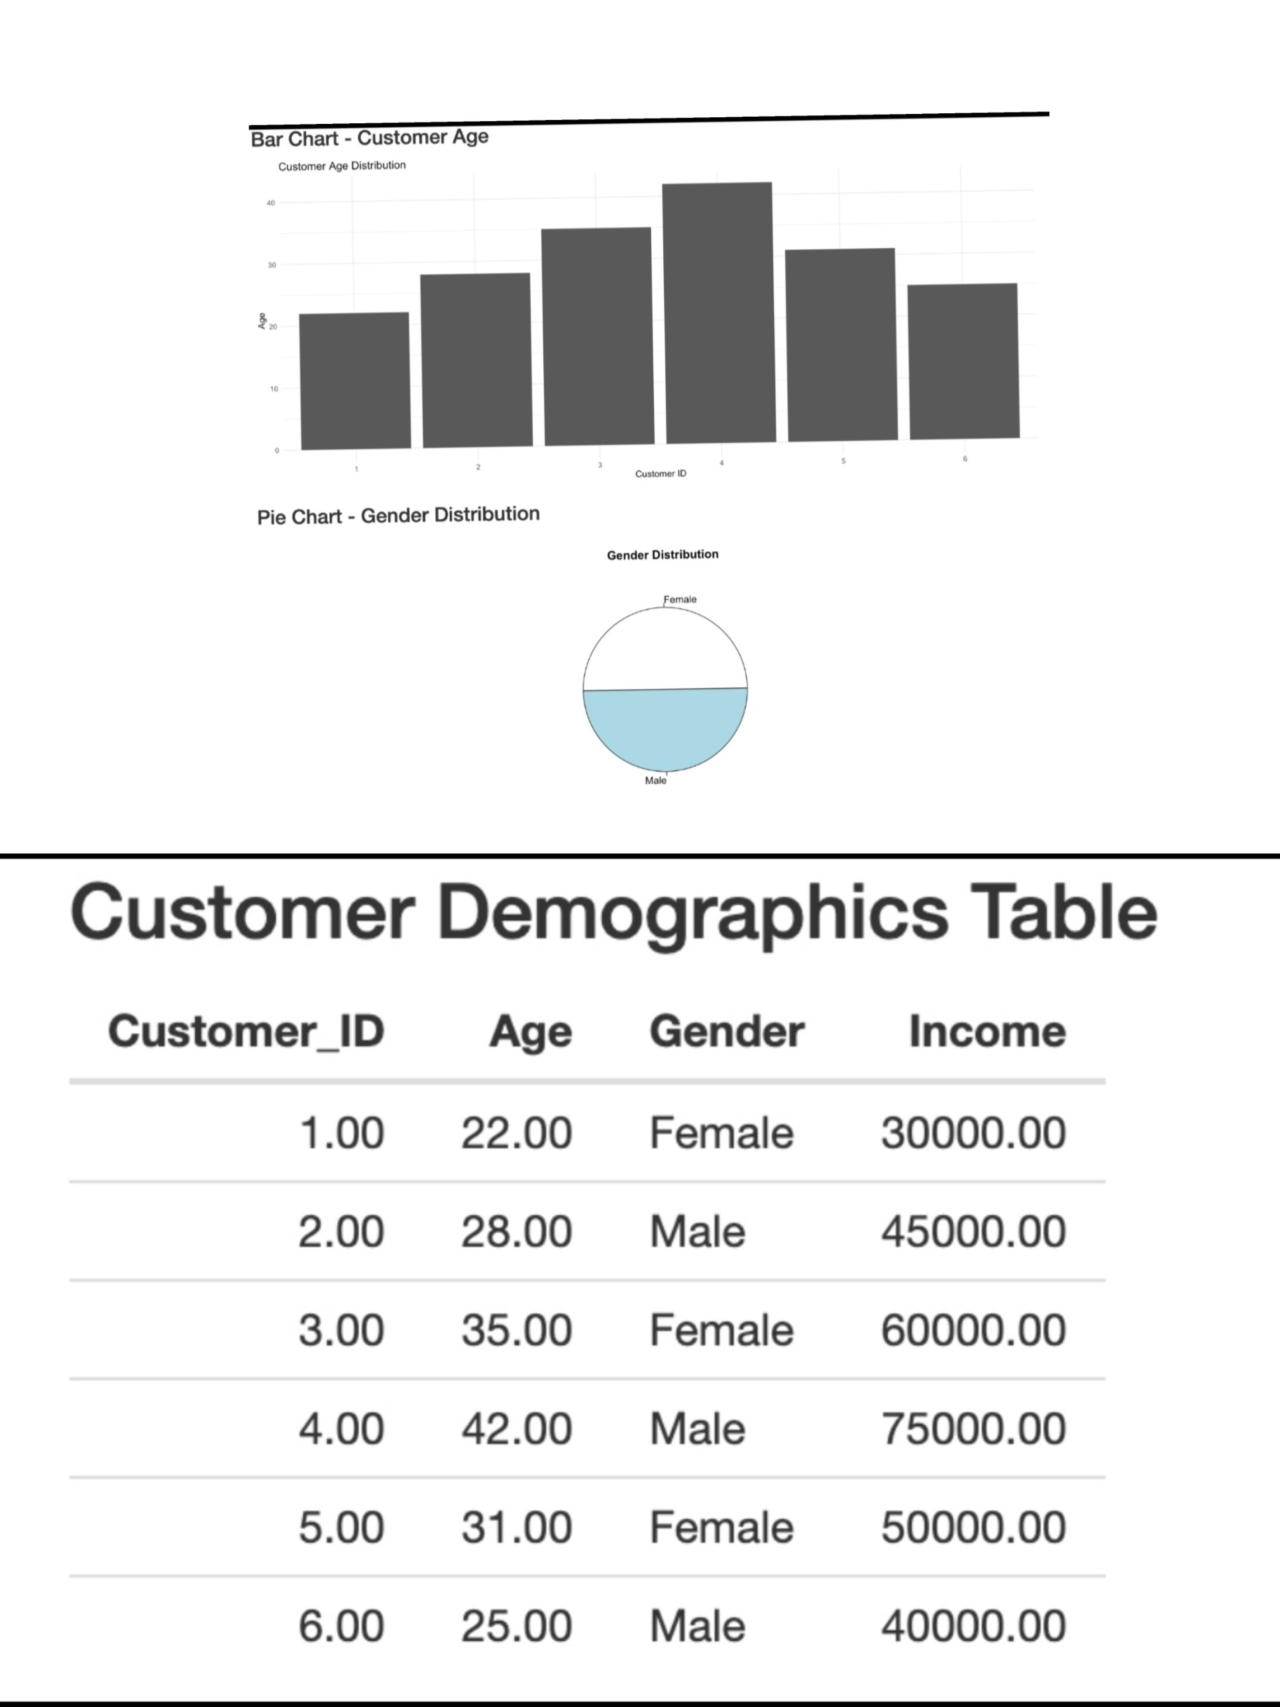
Output 4: Tableau Dashboard of Customer Demographics
Observation: The dashboard presents the bar chart, pie chart and demographics table together on one page, so customers can be explored interactively by age, gender and income.
Procedure
1. Create the customer data frame in R with Customer ID, Age, Gender and Income.
2. Use barplot() to plot customer ages with labelled axes and a title.
3. Use table() to count customers by gender and pie() to draw the pie chart.
4. Rename the columns with colnames() and display the data frame as a labelled table.
5. Load the data in Tableau, create the three sheets, and combine them in a dashboard with filter actions.
Result
The customer demographics data was successfully visualized using a bar chart for age, a pie chart for gender distribution, and a labelled table. An interactive Tableau dashboard combining all three views was also created.
Key Functions Used
Function | Purpose
data.frame() | Creates the customer dataset.
barplot() | Creates the bar chart of ages.
table() | Counts customers by gender.
pie() | Creates the pie chart.
colnames() | Labels the table columns.

